1. How to find the first non repeated character of a given String?

import java.util.*;

public class Main {

public static void main(String[] args) {

String str1 = "gibblegabbler";

System.out.println("The given string is: " + str1);

for (int i = 0; i < str1.length(); i++) {

boolean unique = true;

for (int j = 0; j < str1.length(); j++) {

if (i != j && str1.charAt(i) == str1.charAt(j)) {

unique = false;

break;

}

}

if (unique) {

System.out.println("The first non repeated character in String is: " + str1.charAt(i));

break;

}

}

}

}

**Output:**

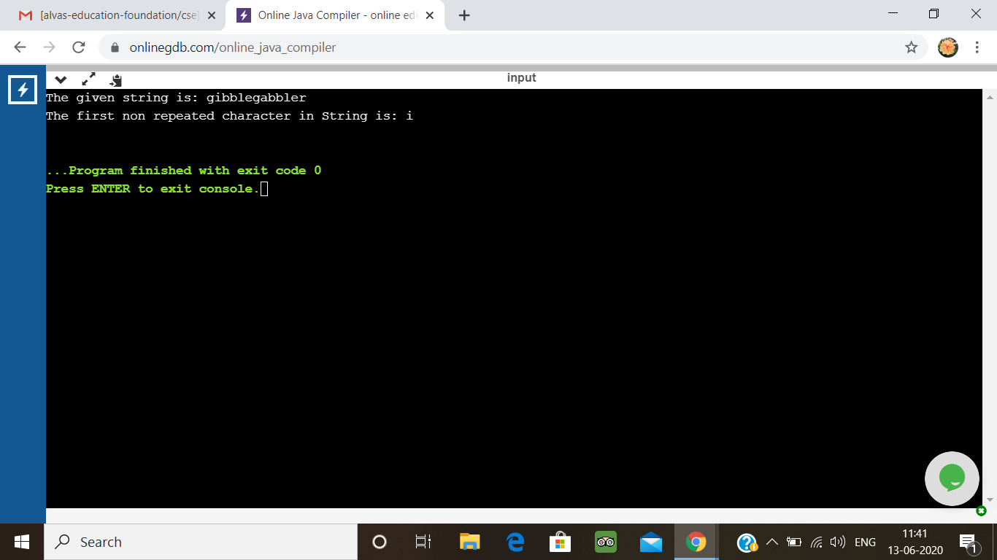

2. Write a Java Program to determine whether a given matrix is a sparse matrix

Description:  
Algorithm  
STEP 1: START  
STEP 2: DEFINE rows, cols, size  
STEP 3: SET count = 0  
STEP 4: INITIALIZE first matrix a[][] ={{4,0,0}, {0,5,0}, {0,0,6}}  
STEP 5: rows = a.length  
STEP 6: cols = a[0].length  
STEP 7: size = rows*cols  
STEP 8: REPEAT STEP 9 to STEP 10 UNTIL i<rows  
//for(i=0;i<rows; i++)  
STEP 9: REPEAT STEP 10 UNTIL j<cols  
//for(j=0;j<cols; j++)  
STEP 10: if(a[i][j]==0) then count++  
STEP 11: if(count>size/2) then PRINT "Yes" else PRINT "No"  
STEP 12: END

public class Main

{

public static void main(String[] args) {

int rows, cols, size, count = 0;

int a[][] = {

{4, 0, 0},

{0, 5, 0},

{0, 0, 6}

};

rows = a.length;

cols = a[0].length;

size = rows * cols;

for(int i = 0; i < rows; i++){

for(int j = 0; j < cols; j++){

if(a[i][j] == 0)

count++;

}

}

if(count > (size/2))

System.out.println("Given matrix is a sparse matrix");

else

System.out.println("Given matrix is not a sparse matrix");

}

}

**Output:**

